DATA GUARD SWITCH OVER AND SWITCH BACK OPERATIONS

By Simon Musisi



**Document Control**

**Version**

|  |  |  |  |
| --- | --- | --- | --- |
| S/N | Version | Release | Date |
| 1 | 3.0 | Second Version | 06/06/2017 |

**Changes**

|  |  |  |
| --- | --- | --- |
| S/N | Version | Description of challenges |
| 1 | 3.0 | 1. Updated the document to include basic commands that can be understood by non-technical people. |

**Preparation**

|  |  |  |  |
| --- | --- | --- | --- |
| Preparation | Name | Date | Signature |
| Reviewed by | Simon Peter Musisi | 06/06/2017 |  |
| Reviewed by | Chris Musoke | 06/06/2017 |  |

Concurrence

|  |  |  |  |
| --- | --- | --- | --- |
| Designation /Unit | Name | Date | Signature |
| Group Head, Technology | Edward Serubanja | 06/06/2017 |  |

Database Administrator

Guaranty Trust Bank (Uganda) Limited

**Disclaimer:** The information contained in this document is confidential information. Its purpose is to communicate the details of Guaranty Trust Bank (Uganda) Limited. All information is to be kept confidential and used only to determine the feasibility and acceptability of the proposed solution. This document is the property of, and is proprietary to GTBank Uganda. It is not to be disclosed in whole or in part without the express written authorization of GTBank, shall not be duplicated or used, in whole or in part for any purpose other than to evaluate GTBank’s proposal. [itsupportug@gtbank.com](mailto:itsupportug@gtbank.com)

INTRODUCTION

As transactions occur in the primary database, *redo data* is generated and is written to the *local redo logs*. Oracle Data Guard automatically transfers this *redo data* to the standby sites and applies it to the standby DR database, synchronizing it with the primary database. This ensures that at any point in time the transactions on the primary database should reflect in the standby DR database so that either of the two databases can play the role of the other.

There are situations when the primary database may be temporarily unreachable, and this requires for a solution of switching the standby DR database to be the primary database as issues with the primary database are being sorted out, this is referred to as database switchover.

This document covers the following;

* Switch over, switching between the primary and the standby DR database i.e making the standby database the primary in and making the primary database the standby database
* Switch back, switching between the standby DR and the primary database i.e. restoring the original primary database to its primary role and restoring the original standby database to its role.

1. **SWITCH OVER (Make standby DR database new primary database)**

Login to the primary and DR databases and check whether the logs are applied and the logs sequence matches in both

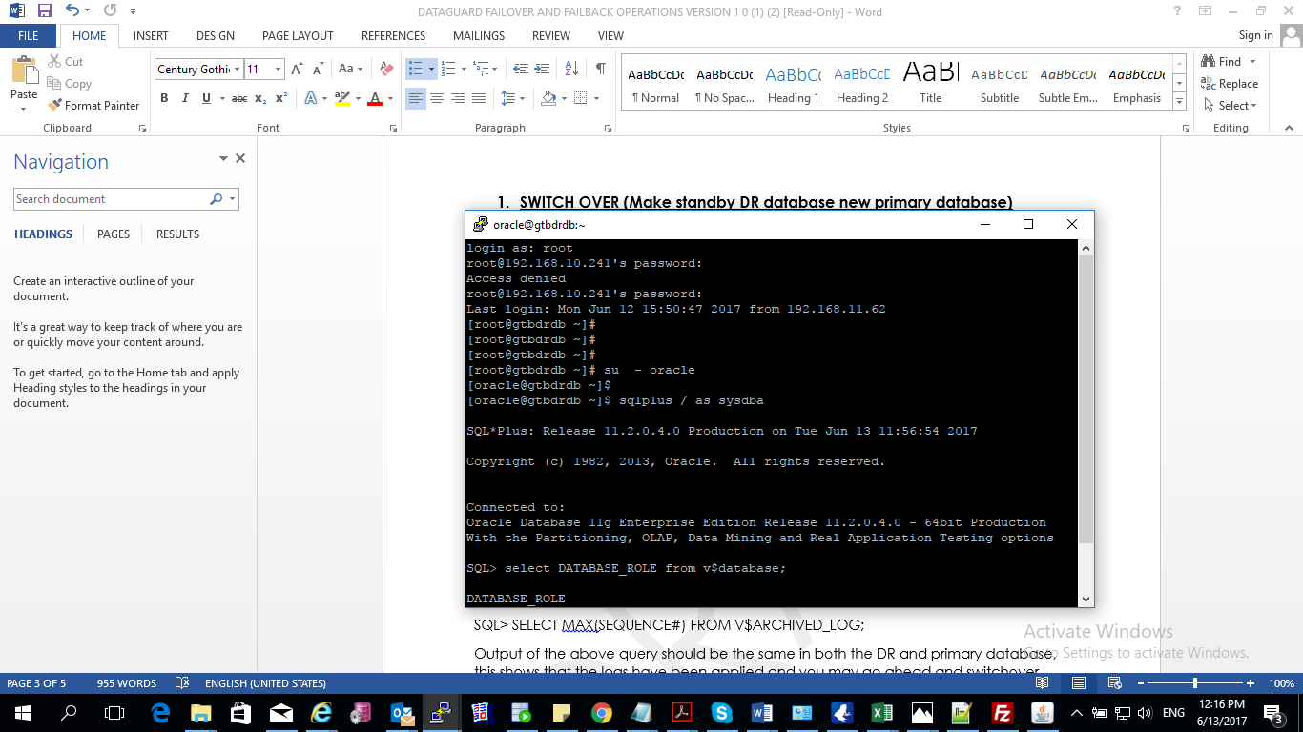

* Login using Username e.g. smusisi in the primary
* Similar users have been created on the DR e.g. smusisi on DR

Open putty

Sudo su – oracle

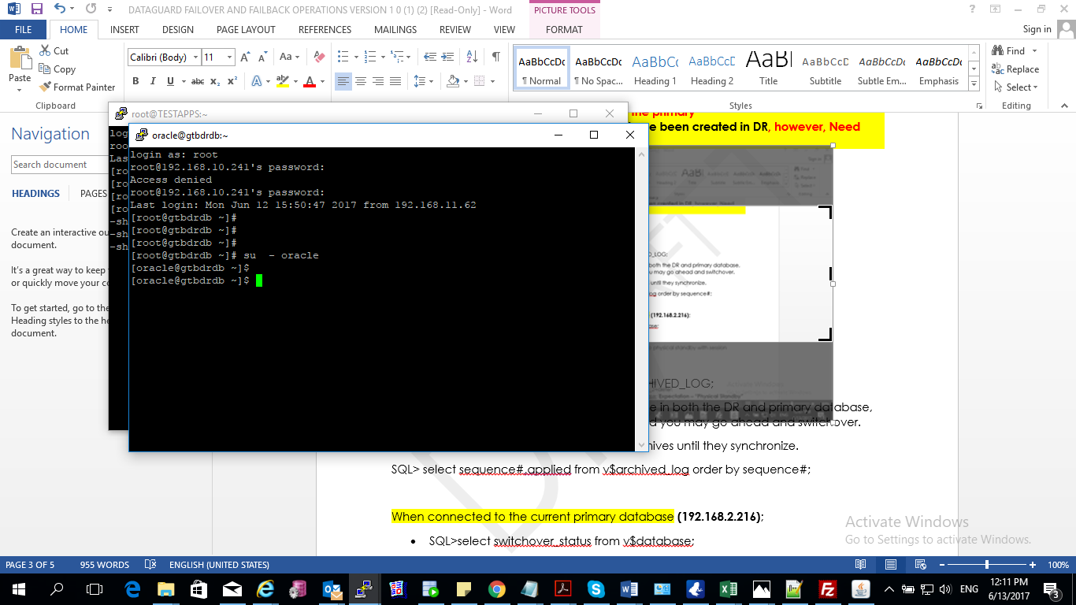

SQL> sqlplus / as sysdba

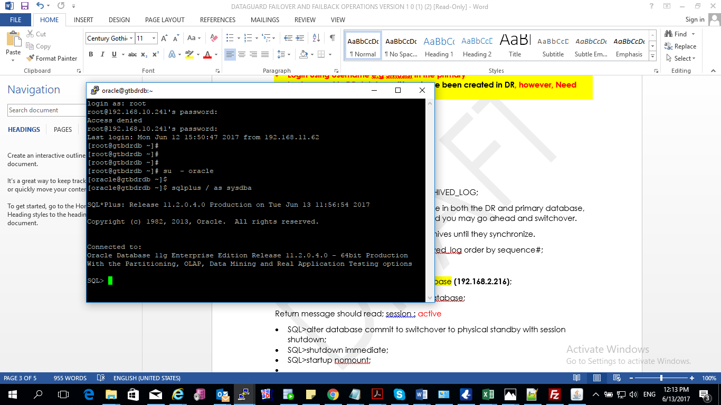

SQL> SELECT MAX(SEQUENCE#) FROM V$ARCHIVED_LOG;

Output of the above query should be the same in both the DR and primary database, this shows that the logs have been applied and you may go ahead and switchover.

If not, use the statement below to see the archives until they synchronize.

SQL> select sequence#,applied from v$archived_log order by sequence#;

When connected to the current primary database **(192.168.2.216)**;

* SQL>select switchover_status from v$database;

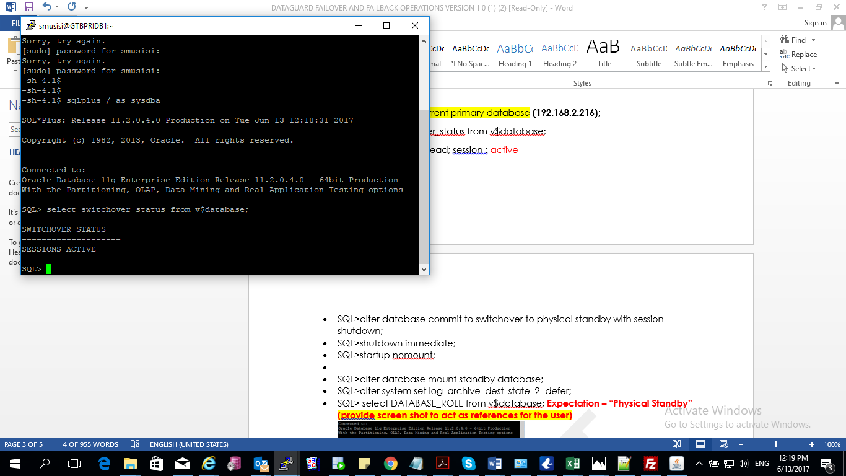

Return message should read; session : active

* SQL>alter database commit to switchover to physical standby with session shutdown;
* SQL>shutdown immediate;
* SQL>startup nomount;
* SQL>alter database mount standby database;
* SQL>alter system set log_archive_dest_state_2=defer;
* SQL> select DATABASE_ROLE from v$database;
* Expectation – “Physical Standby”

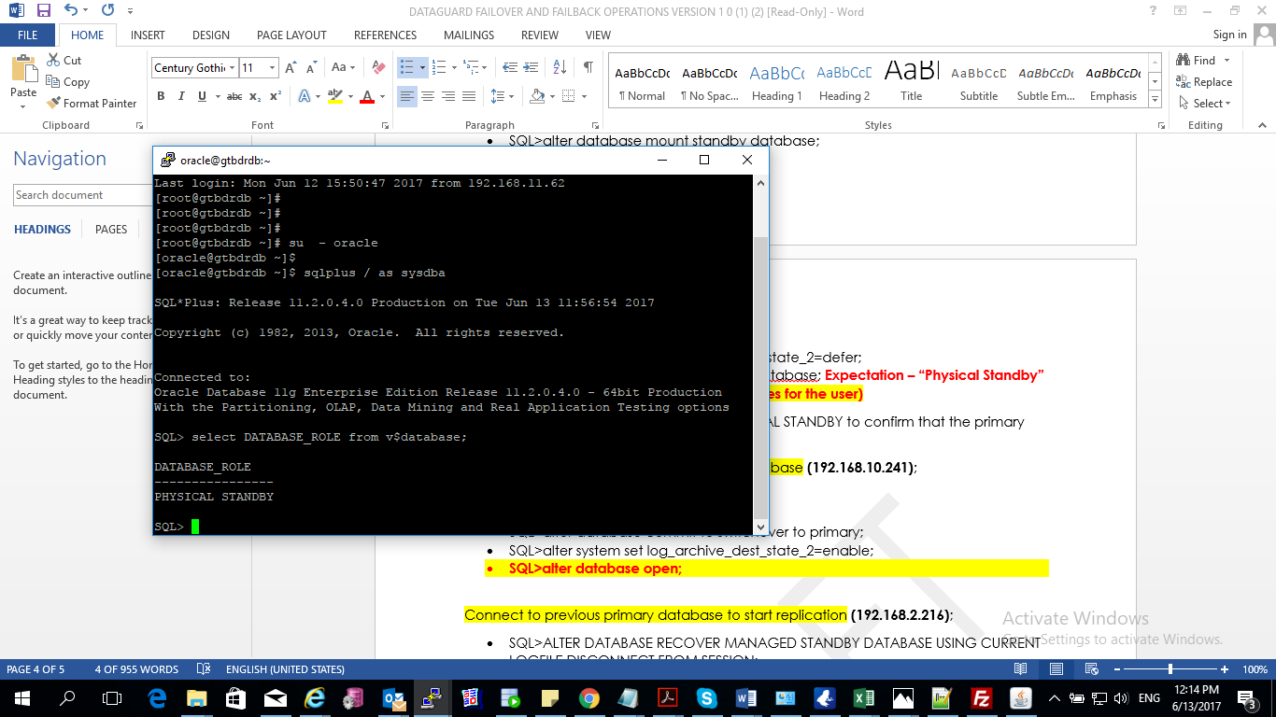

Output of the above query should be PHYSICAL STANDBY to confirm that the primary database is now the standby database.

When connected to the current standby database **(192.168.10.241)**;

* SQL>shutdown immediate;
* SQL>startup;
* SQL>alter database commit to switchover to primary;
* SQL>alter system set log_archive_dest_state_2=enable;
* **SQL>alter database open;**

Connect to previous primary database to start replication **(192.168.2.216)**;

* SQL>ALTER DATABASE RECOVER MANAGED STANDBY DATABASE USING CURRENT LOGFILE DISCONNECT FROM SESSION;

Connect to new primary database **(192.168.10.241)**;

* SQL>alter database open
* SQL>ALTER SYSTEM SWITCH LOGFILE;

Open the log file on the standby database server to check replicating is as expected (192.168.2.216)

Login as oracle

[oracle@gtbdrdb ~]$ tail –f /u01/app/oracle/diag/rdbms/hobank/HOBANK/trace/alert_HOBANK.log

* Output should be like: **Archived Log entry 157 added for thread 1 sequence 16055 ID 0x300f40bc dest 1:**

Run webpar script

1. **SWITCH BACK (Restore primary database from DR database)**

Login to the primary and DR databases and check whether the logs are applied and the logs sequence matches in both

SQL> SELECT MAX (SEQUENCE#) FROM V$ARCHIVED_LOG;

Output of the above query should be the same in both the DR and primary database, this shows that the logs have been applied and you may go ahead and switchback.

When connected to the current primary database **(192.168.10.241)**;

* SQL>alter database commit to switchover to physical standby with session shutdown;
* SQL>shutdown immediate;
* SQL>startup nomount ;
* SQL>alter database mount standby database;
* SQL>alter system set log_archive_dest_state_2=defer;
* SQL> select DATABASE_ROLE from v$database;

Output of the above query should be PHYSICAL STANDBY to confirm that the primary database is now the standby database.

When connected to the current standby database **(192.168.2.216)**;

* SQL>shutdown immediate;
* SQL>startup;
* SQL>alter database commit to switchover to primary;
* SQL>alter system set log_archive_dest_state_2=enable;

Connect to previous primary database to start replication **(192.168.10.241)**;

* SQL>ALTER DATABASE RECOVER MANAGED STANDBY DATABASE USING CURRENT LOGFILE DISCONNECT FROM SESSION;

Connect to new primary database **(192.168.2.216)**;

* SQL>ALTER SYSTEM SWITCH LOGFILE;

Open the log file on the standby database server to check replicating is as expected **(192.168.10.241)**

Login as oracle

[oracle@gtbdrdb ~]$ tail –f /u01/app/oracle/diag/rdbms/hobankdr/HOBANKDR/trace/alert_HOBANKDR.log

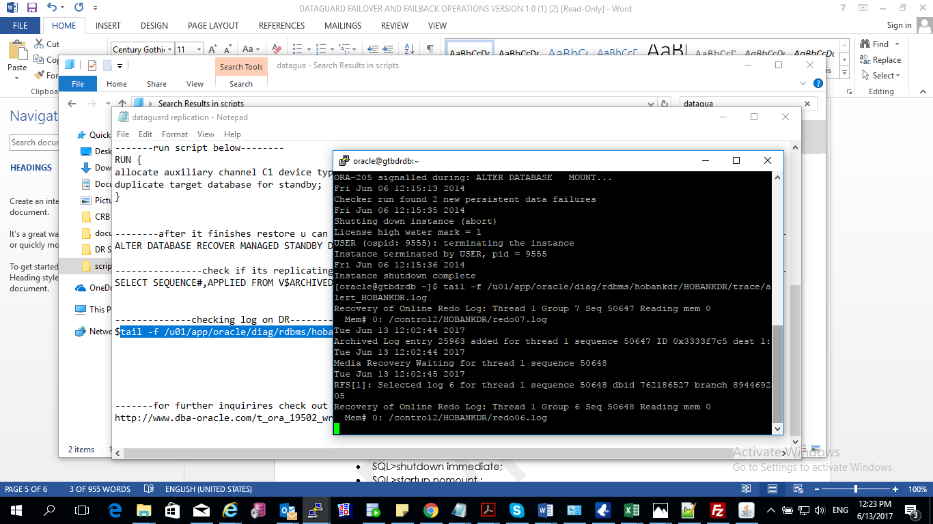

Output should be like: **Archived Log entry 157 added for thread 1 sequence 16055 ID 0x300f40bc dest 1:**

**CONTACT INFORMATION**

Musisi Simon 0756439980

Chris Musoke 0778082155